University Campus Network Design Report
Yasser Zaher 202201077
Yehia Hesham 202202135
Mostafa Mohamed 202202060
Ahmed Wael 202201415

1. Introduction
- Objective: Design a network for a small university campus.
- Purpose: Connect multiple faculties, labs, and a Scientific Computation Center efficiently, ensuring access to internal and external networks.
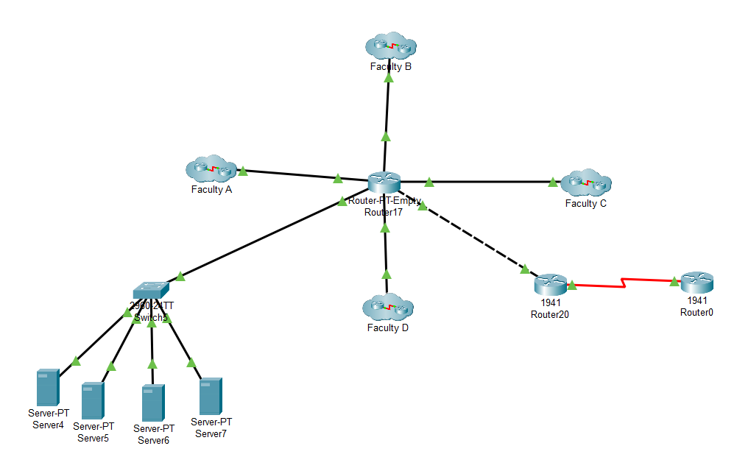
- Scope: Includes routing, VLAN implementation, and star topologies.

2. Network Design Requirements
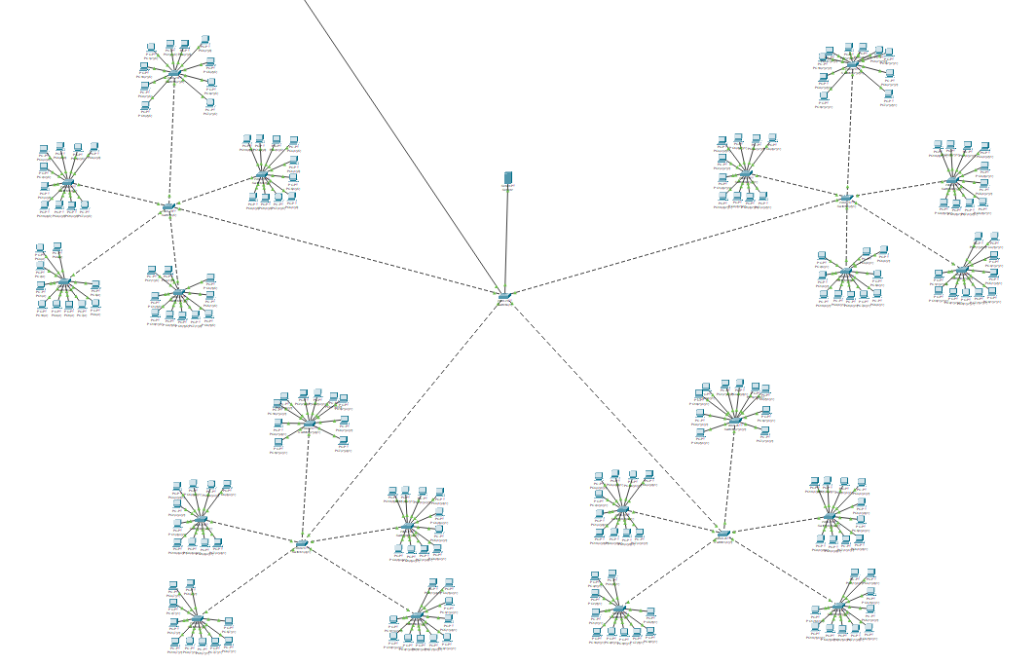
- Faculties: 4 faculties, each with 4 floors.

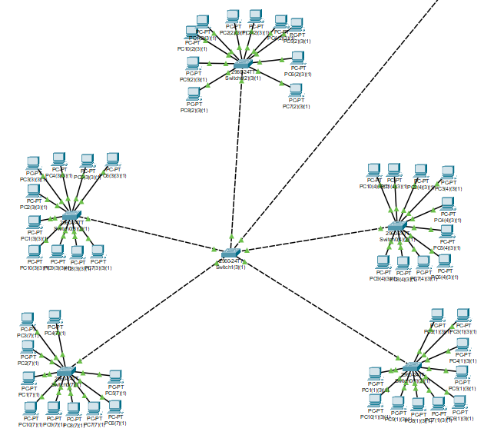
- Labs: Each floor contains 5 labs, each with 10 PCs connected via switches.

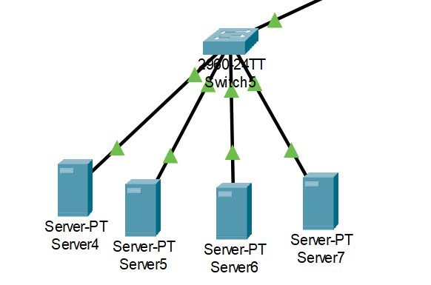
- Scientific Computation Center: Contains several servers connected by a switch.

- Connections:
  - All lab switches on a floor connect to a floor switch.
  - Floor switches connect to a main faculty switch.
  - The main faculty switch and Scientific Computation Center connect to the university router.
- External Connectivity: The university router links to the World Wide Web.
3. IP Addressing
- Classless IP addressing optimizes the use of public IP addresses across networks.
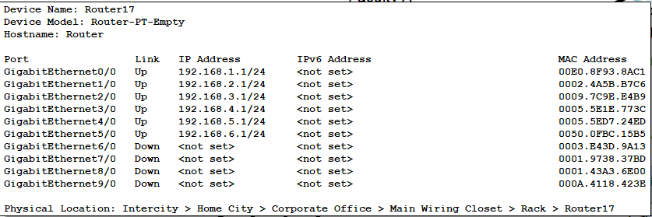
4. Topologies
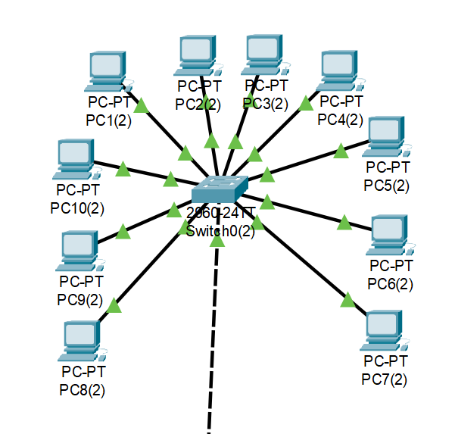
- Labs: star topologies.

5. Routing and VLAN
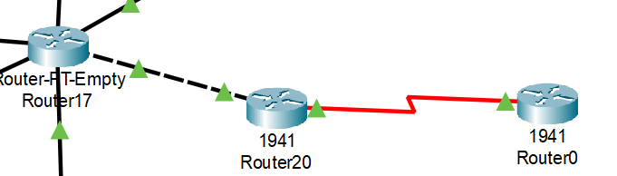
- RIP (Routing Information Protocol) for inter-faculty and center data routing.

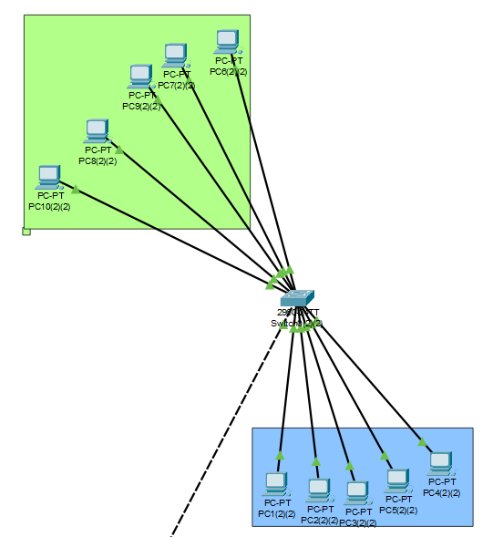
- VLAN configurations to segment network traffic efficiently.

6. Test Scenarios
- Scenario 1: A PC from Lab 2 on the first floor of the Faculty of Computers & AI accesses data from Server 0 in the Scientific Computation Center.
  - Source IP: PC 0 IP.
  - Destination IP: Server 0 IP.
- Scenario 2: VLAN communication is tested between labs of different faculties.
- Scenario 3: Internet connectivity is verified for a lab PC.
